Faculty ???
Branch of study: ??????
Major: ???????

CFD Simulations of Power Generation Units

Report …

Title

Name and surname

Group
day, time

………………... | …………………… | .…………………… | ………………..
Date of execution | Date of submission | Date of return | Date of acceptance

Lecturer: | dr inż. Przemysław Błasiak | ....................... | .......................
 |  | mark | signature

Wrocław 2018

Table of Contents
1. Introduction 2
2. Numerical model 2
3. Results and discussion 4
4. Conclusions 4
5. References 4

Introduction
The aim of the exercise is to familiarize with the basic workflow while conducting numerical simulations of fluid flow using the ANSYS CFX software.
Numerical calculations will be made for the sample geometry shown in Fig. 1. A two-dimensional flow of water in a straight channel inside which an orifice (narrowing) will be modeled.
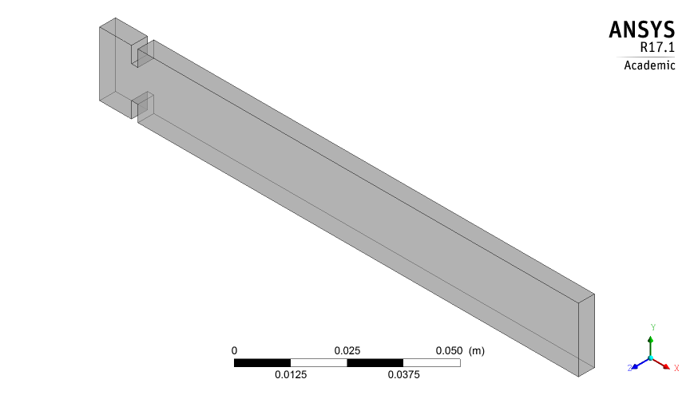
Inlet
Outlet
Walls
Orifice
Side surfaces
Fig. 1. Geometrical model of two-dimensional fluid flow in a duct

Numerical model
In order to model the problem of two-dimensional water flow in a pipe, one should divide the three-dimensional geometric model into smaller elements called finite volumes, i.e. create a so-called numerical mesh. The view of the numerical mesh is shown in Fig. 2. The numerical mesh used here is called non-uniform mesh, in which the mesh elements are not evenly spaced in opposite to the so-called a uniform numerical mesh. Near the narrowing the number of mesh elements is large (mesh density), while away from the inlet, the density of the mesh elements decreases. It results from the principle in which the numerical mesh should be dense in places where large gradients (changes) in speed, pressure, temperature etc. are expected. In contrast, the use of non-uniform mesh allows to reduce the number of mesh elements compared to a uniform mesh, and cosequently significantly reduces the calculation time that increases as the number of mesh elements rises. The numerical mesh used consists of 2716 hexahedral elements.
The numerical mesh is a division of the computational area (numerical domain) into elementary cells. Next, for each cell the equations of mass (1) and momentum (2) are solved. These are partial differential equations for which an analytical solution can be obtained only for simple cases (e.g. two-dimensional laminar flow in a straight channel without narrowing). These equations are written for the case of non-compressible fluid flow because in the calculations water will be treated as an incompressible fluid. In equations (1) and (2), u is the absolute velocity vector, t time, p pressure, ρ density, and ν kinematic viscosity. Equations (1) and (2) are called Navier-Stokes equations for incompressible fluid. The physical properties of water used in calculations can be found in Tab. 1.

(1)

(2)

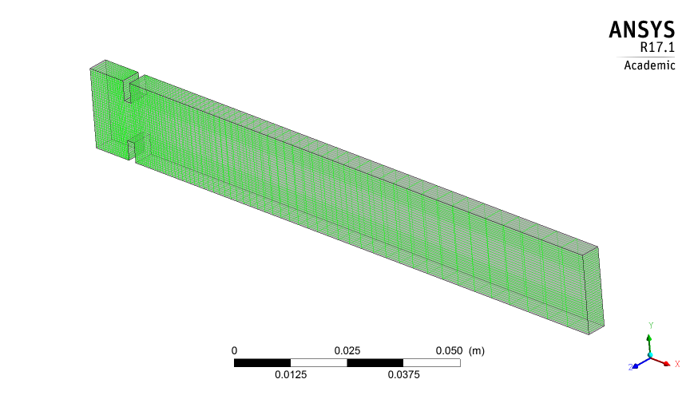
Fig. 2. Non-uniform numerical mesh used in calculations

Tab. 1. Thermophysical properties of water
ρ  kg/m3 | c_{p}  J/kg/K | η  Pa s | λ  W/m/K
997.0 | 4181.7 | 0.0008899 | 0.6069

In order to solve the given problem, the boundary and initial conditions should be provided. Due to the fact that the two-dimensional flow is modeled, the mesh in the direction perpendicular to the flow has only one element. On the side surfaces a boundary condition of the symmetry type was applied. The combination of applied boundary conditions is shown in Tab. 2. At the initial moment, it was assumed that the water in the channel is stationary. The calculation was carried out for a flow time of 0.1 s with a time step of Δt = 0.001 s.
Tab. 2. Boundary conditions applied in calculations
Surface | Boundary condition type | Value | Unit
Inlet  Outlet  Walls  Orifice  Side surfaces | Inlet  Outlet  Wall  Wall  Symmetry | 1  10⁵  0  0  - | m/s  Pa  m/s  m/s  -

Results and discussion
Fig. 3 shows the distribution of velocity vectors at time t = 0.1 s. At the inlet to the channel an even velocity distribution resulting from the boundary condition of the constant velocity of 1 m/s is visible. As a result of the sudden narrowing of the channel, the streamlines are curved in the direction of the channel axis and there is an increase in velocity just before the narrowing. In the place of the smallest geometric cross-section, the speed is about twice as high as at the inlet, but there is no maximum speed at this point. The largest velocity zone begins around one channel diameter behind the narrowing and extends further along the length of about two channel diameters. Fig. 3b shows exactly the phenomenon of stream contraction, i.e. the occurrence of its narrowing after geometric constraint and the associated increase in velocity. In the part of the channel behind the orifice, in its axis, the velocity, however, continues to grow, which is not justified in any way, because energy does not flow from the outside and no further narrowing of the stream takes place. This is due to numerical errors and the assumption that the flow is laminar, while it is turbulent (Re ≈ 20,000). Fig. 4 shows a more realistic speed distribution obtained using the k-ε turbulence model. The recirculation zones characteristic for this type of flow are visible, forming behind a geometric obstacle in the upper and lower part of the channel.
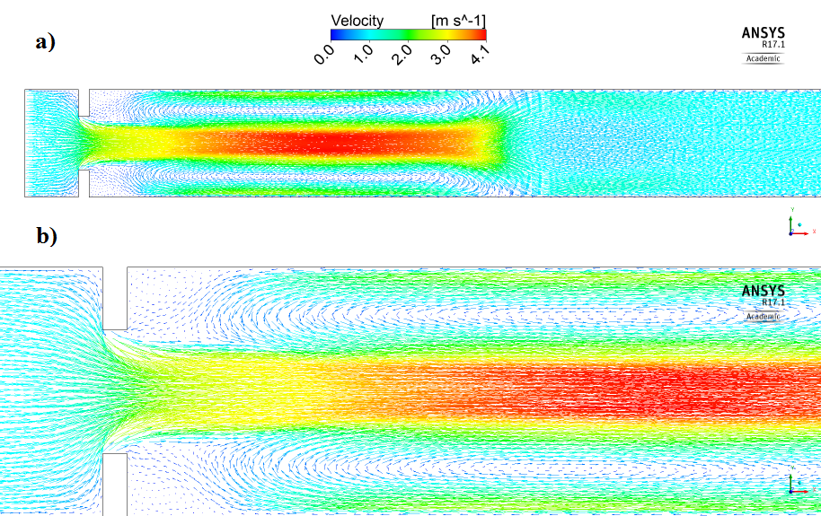
Fig. 3. Distribution of velocity vectors in a channel assuming that the flow is laminar;
a) general view, b) detailed view of the narrowing
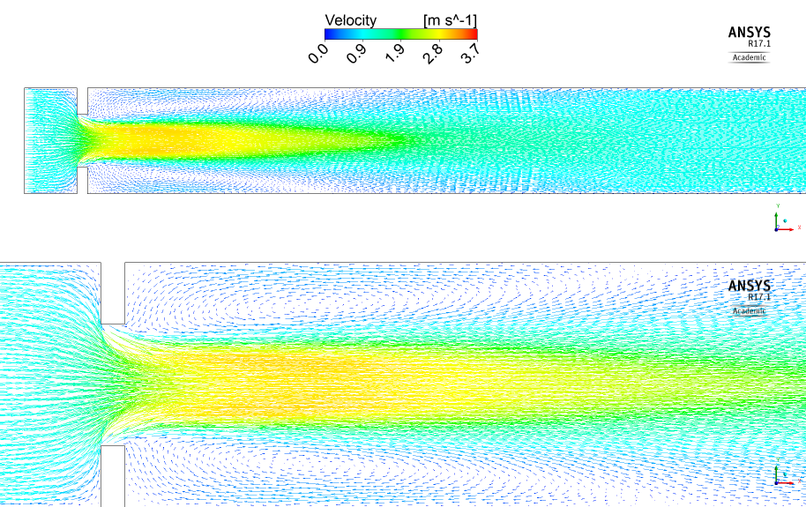
Fig. 4. Distribution of velocity vectors in a channel assuming that the flow is turbulent (turbulence model k-ε); a) general view, b) detailed view of the narrowing

Conclusions
The exercise involved numerical analysis of two-dimensional water flow in a straight channel. Based on the given geometry, the numerical model of the problem was set up and the boundary and initial conditions were determined. The calculations were made with the assumption of laminar flow, however, the results turned out to be unrealistic due to the unexpected acceleration of the stream in the channel axis at a large distance after the orifice. For this reason, calculations have been corrected assuming that the flow is turbulent. The k-ε turbulence model was used for the calculations. The following conclusions can be drawn from the exercise:
- The standard workflow in the ANSYS CFX program includes: description of the problem, preparation of a geometric model, creation of a numerical mesh, preparation of a numerical model, setting up material features, assigning boundary and initial conditions, solving the problem, developing and interpreting the results.
- Before starting the calculations, it is very important to estimate the type of flow (laminar, transitional, turbulent). Poor selection of the turbulence model may result in large numerical errors and in receiving erroneous results that deviate significantly from reality.
- The laminar model is not suitable for calculations in the case of turbulent flows due to the significant over-estimation of velocity results.

References

[1] …
[2] …
[3] …

